

School of Informatics & IT

Application Development Project (45%)
Database Application Development (35%)
(System Code Implementation)
AY 25/26 Oct Semester
Project 2 Report

Contents
Declaration of Originality 3
ADEV Part 2: System Code Implementation (45%) 5
Frontend Features Implementation (25%) 6
User Interface (10%) 6
Additional Feature (5%) 7
DBAV Part 2: System Code Implementation (35%) 8
API Implementation (20%) 9
Additional Feature (5%) 9
Error Handling (10%) 10

SCHOOL OF INFORMATICS & IT

Diploma in [Applied Artificial Intelligence ]

Project 2 Report

Student Name (Matric Number) : Leon Jr Chua

Tutorial Group : TC23
Jenny LING (TP)
Tutor : Mr Alfred Teng

Submission Date :

Declaration of Originality

I am the originator of this work and I have appropriately acknowledged all other original sources used as my references for this work.

I understand that Plagiarism is the act of taking and using the whole or any part of another person’s work, including work generated by AI, and presenting it as my own.

I understand that Plagiarism is an academic offence
and if I am found to have committed or abetted the offence of plagiarism in relation to this submitted work, disciplinary action will be enforced.

Declaration on the use of Generative AI tools for assignments

Describe how you have used Generative AI tools such as ChatGPT or Dall.E- in your assignment.

Share the link to the conversations you had with the AI tool (i.e., the prompts you used and the responses you get from the AI tool).

Please refer to this PDF on “How to share the conversations made with ChatGPT?”

How do you indicate the reference?
The content generated by AI tools are not retrievable except by the user who generated them, so they are considered non-recoverable sources. Although non-recoverable data or quotations in APA Style papers are usually cited as personal communications, with ChatGPT-generated text there is no person communicating. Quoting text from ChatGPT chat is therefore more like sharing the output of an algorithm, with a reference list entry and the corresponding in-text citation.
According to the official APA Style site, ChatGPT references should be cited as:
E.g. OpenAI. (2024). ChatGPT (Feb 13 version) [Large language model].
https://chat.openai.com/chat

Note: The information in parentheses refers to the update or revision date of the model used. Refer to the release notes in the ChatGPT application.

Important Note:

- Do not copy answers produced by the AI tool in totality as it is considered as plagiarism.

- Do not rely on any information produced by the AI tool blindly. You should always verify the answer with other sources. Do not assume that these answers provided by the AI tool are correct.

- To achieve quality outputs from the AI tool, you should provide good prompt that is clear and specific. Be precise and provide context. Avoid asking open-ended questions.

ADEV Part 2: System Code Implementation (45%)

Frontend Features Implementation (25%)
List down all the URL to the different pages of the website.
Provide the sample input values if any.
URL | Purpose | Inputs
http://localhost:8080/public_homepage.html | Home Page to view all animals, for public access. Stat cards at the top show number of animals in each adoption status, clicking on a statistic card filters the animal listings to display only animals with the selected adoption status. The purpose of the Public Home Page is to provide the public with a clear and accessible overview of all animals available for adoption, while allowing users to quickly browse and narrow down listings based on adoption status. | Although there are buttons on the page (Add animals, View) these buttons do not collect value. Instead, they function as navigation controls that trigger page redirection.  Users can interact with the statistic cards by clicking on them, which serves as a user input to filter the animal listings based on the selected adoption status.
http://localhost:8080/public_animaldetails.html?id=12 | The Public Animal Details page provides users with detailed information and image/s of a selected animal to help users make an informed decision in adoption | Although there are buttons on the page (Animals, add animals) these buttons do not collect value. Instead, they function as navigation controls that trigger page redirection.  Users can interact with image thumbnails (if animal has multiple images), which act as input controls, when a thumbnail is clicked, it triggers an update to the main image displayed on the page
http://localhost:8080/add_animals.html?from=public | Add animal page to allow users to add new animals records to the database for display on the website. It also uses a query parameter to manage navigation and redirect users back to the appropriate homepage  Eg, ?from=public results in user being redirected to public homepage if they choose to go back to home | Although there are buttons on the page (Animals, add animals) these buttons do not collect value. Instead, they function as navigation controls that trigger page redirection.  Sample Mandatory Inputs for updating animals  - Name  - Age(year)  - Age(month)  - Gender  - Species  - Breed  - Temperament/ personality  - Adoption status  - Default image URL  Optional inputs for adding animals  - Extra images URL  Sample input  - Jami  - 1  - 3  - Female  - Dog  - Golden Retriever  - Cheerful and active  - Available  - https://www.rover.com/blog/wp-content/uploads/2018/11/golden-retriever-2061715_1920.jpg  The page also includes button inputs for managing additional images, allowing users to dynamically add or remove image URL input fields when required.  The Add Animals button submits the form data and triggers the create API call.
http://localhost:8080/admin_homepage.html | Admin Home Page has the same layout as the Public Animal Homepage but includes additional admin controls on each animal card. Extra buttons such as Edit and Delete are shown, allowing administrators to manage animal records easily from the homepage. These controls are also hidden from public users | Although there are buttons on the page (Add animals, View) these buttons do not collect value. Instead, they function as navigation controls that trigger page redirection.  Users can interact with the statistic cards by clicking on them, which serves as a user input to filter the animal listings based on the selected adoption status.  The Update button functions as an input control that redirects to Update Animal page for the selected record. The Delete button acts as an input control that prompts an alert for confirmation before deleting the selected animal record
http://localhost:8080/admin_animaldetails.html?id=12 | Admin Animal details page to view more images and details about animals contains extra buttons (Edit and Delete). For Admin page | Although there are buttons on the page (Add animals, Animals) these buttons do not collect value. Instead, they function as navigation controls that trigger page redirection.  The Update button functions as an input control that redirects to Update Animal page for the selected record. The Delete button acts as an input control that prompts an alert for confirmation before deleting the selected animal record  Users can interact with image thumbnails (if animal has multiple images), which act as input controls, when a thumbnail is clicked, it triggers an update to the main image displayed on the page
http://localhost:8080/update_animals.html?id=12 | The purpose of the Update Animal page is to allow administrators to modify existing animal records, including updating animal details and managing images so that the adoption information remains accurate and up to date. Also so that new information can be added easily. | Sample Mandatory Inputs for updating animals  - Name  - Age(year)  - Age(month)  - Gender  - Species  - Breed  - Temperament/ personality  - Adoption status  - Default image URL  Optional inputs for adding animals  - Extra images URL  Sample input  - Snoopy  - 1  - 3  - Male  - Dog  - Beagle  - Cheerful and active  - Available  - https://wallpapers.com/images/hd/snoopy-and-bird-the-peanuts-movie-yrtdbzb56hwjj9up.jpg  Administrators provide input through form fields to update animal details.  Image management is handled through button inputs that allow administrators to replace the default image, add additional image URLs, set an image as the default, or delete existing images. Clicking these buttons trigger the respective update actions for the selected animal record.

User Interface (10%)
Provide screenshot(s) of the user interface for each of the core features.
Add more tables if required.

Viewing Home page as admin user
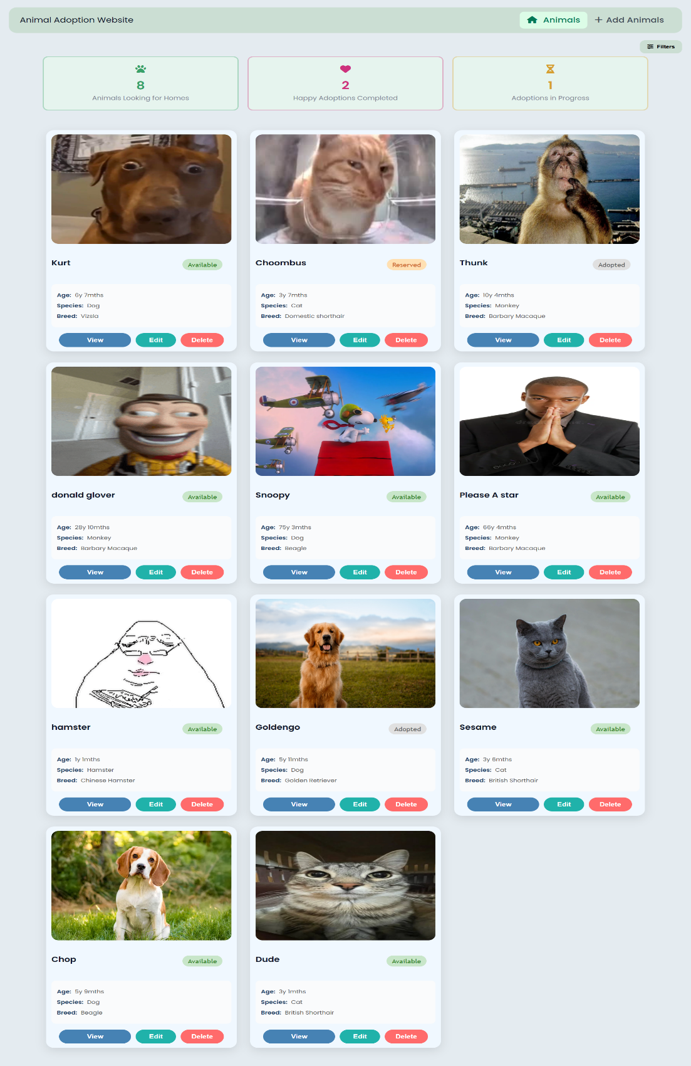
Viewing homepage as public user
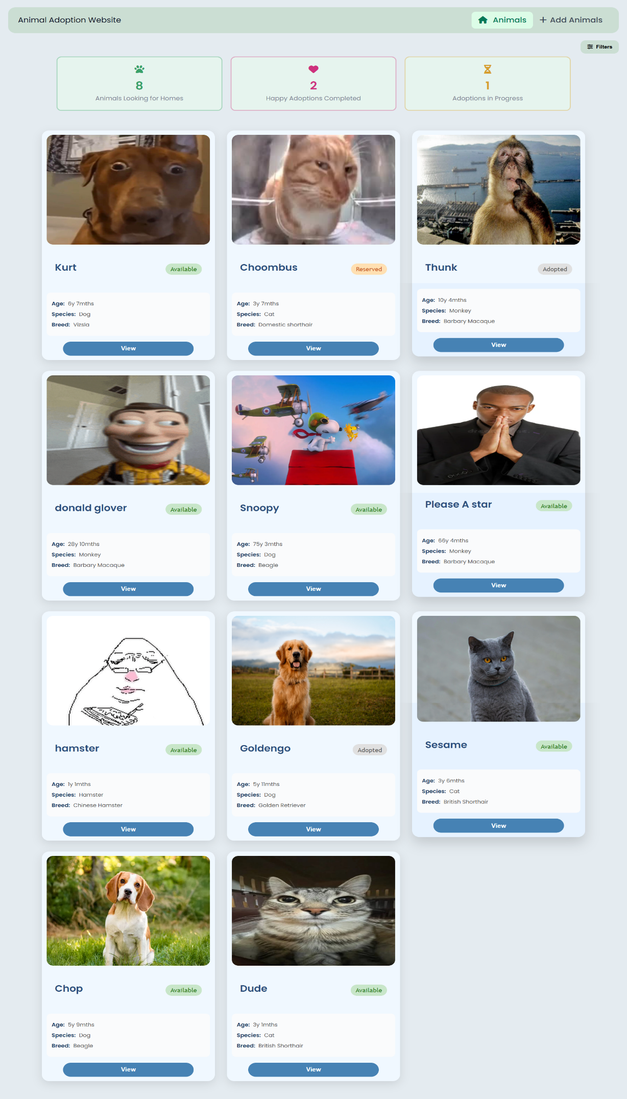
Viewing animal details as admin user
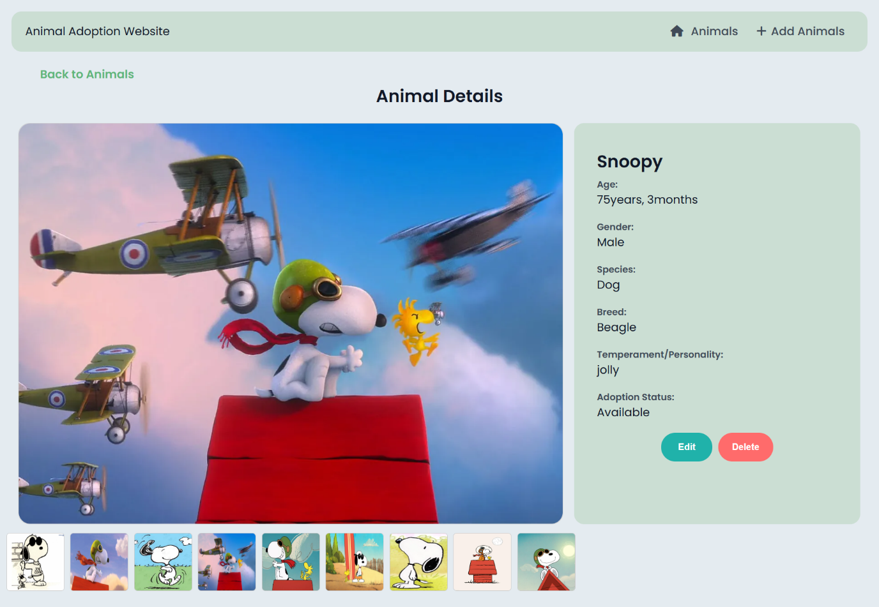
Viewing animal details as public user
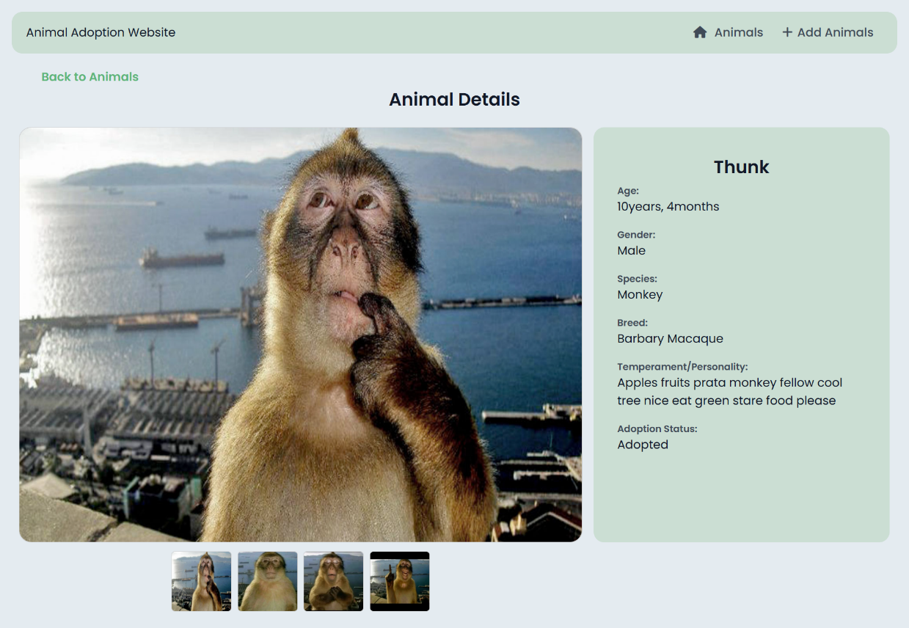
Adding a new animal
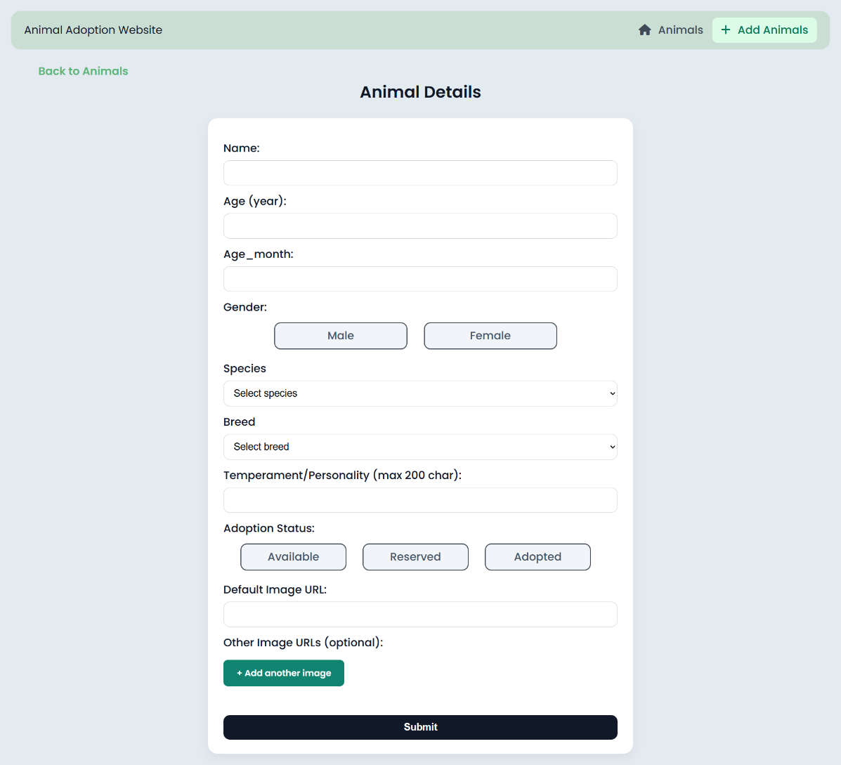
Updating an animals details as admin user
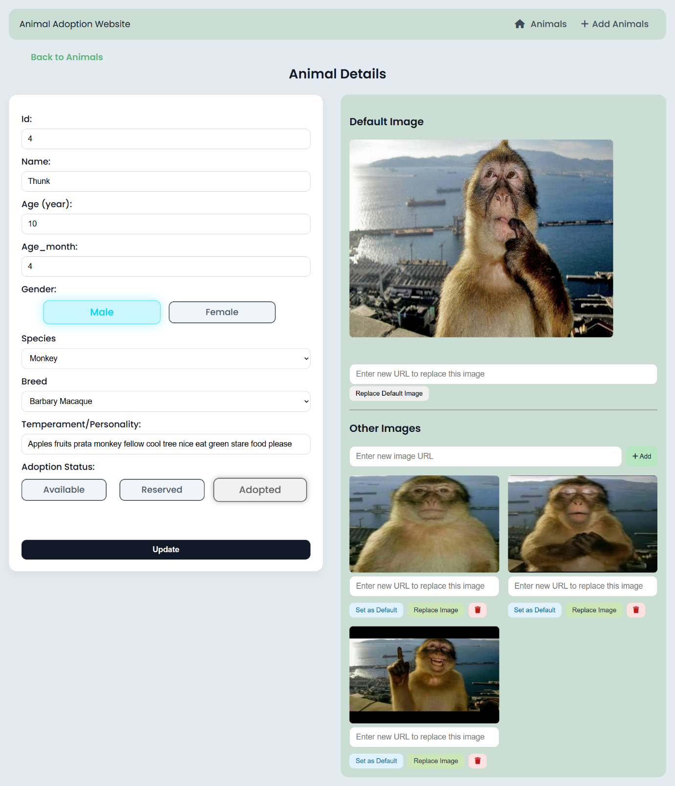

Additional Feature (5%)
Provide screenshot(s) of the additional feature.
Explain how the additional feature enhances your website. Limit your explanation to no more than 150 words :
Additional Feature:
Filters for adoption status and animal species
Screenshots:
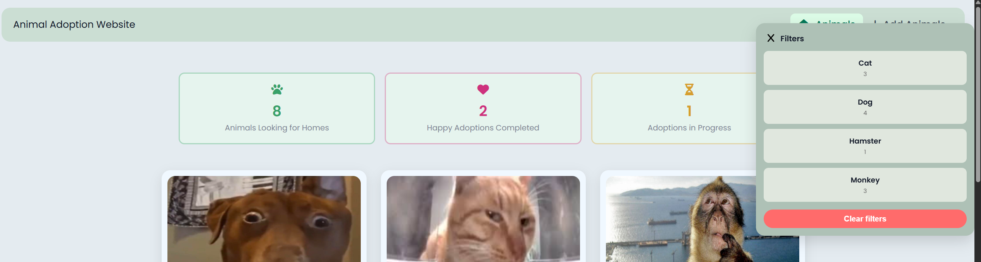
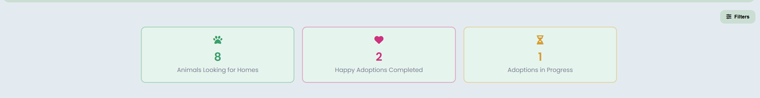
Explanation:
My feature is a multi-filter system that improves how users search for pets in the adoption list. Users can filter animals instantly b adoption status but clicking on any of the status cards at the top, they can further narrow down their search by clicking on the ‘Filters’ button which opens the filter panel.
Filters are populated from database records and applied dynamically using JS after fetching animal data via app route. Both filters update the displayed animals dynamically without reloading the page.
The feature is designed to be user-friendly, selected filters are visually highlighted and the filters can be combined to refine results (select Dog and Available, to view all available dogs). There is a Clear filters option or users can just click back on the same filter to reset the page back to the full list

DBAV Part 2: System Code Implementation (35%)

API Implementation (20%)
Write out the related SQL statement, route pattern, HTTP method and payload (if any) for every functionality (except those related to the additional feature) that your web application has. You will demonstrate to your Lecturer if the functionalities work using Postman based on the routes you created in the route file, and the functions that you wrote in the controller and DB files.

Functionalities of Web Application | Related SQL code  (Full and complete SQL Statements, not partial) | URL Route Pattern | Payload | HTTP Method | Result From Postman  (Pass/Fail)  (To be filled by Lecturer)
GET all animals with breed, species and default image | SELECT animals.*, species.name AS species, breeds.name AS breed, animal_images.image_url FROM animals LEFT JOIN species ON animals.species_id = species.id LEFT JOIN breeds ON animals.breed_id = breeds.id LEFT JOIN animal_images ON animal_images.animal_id = animals.id AND animal_images.is_default = 1; | /animals | N.A. | GET
GET animal details by ID | SELECT animals.*, species.name AS species, breeds.name AS breed, animal_images.image_url FROM animals LEFT JOIN species ON animals.species_id = species.id LEFT JOIN breeds ON animals.breed_id = breeds.id LEFT JOIN animal_images ON animal_images.animal_id = animals.id AND animal_images.is_default = 1; | /animals/id | N.A | GET
Add new animal also create default image | INSERT INTO animal_adoption.animals  (name, age_year, age_month, gender, species_id, breed_id, temperament, adoption_status)  VALUES (?, ?, ?, ?, ?, ?, ?, ?); | /animals | {  "name": "Milo",  "age_year": 2,  "age_month": 1,  "gender": "Male",  "species_id": 1,  "breed_id": 1,  "temperament": "Playful",  "adoption_status": "Available",  "image_url": "images/example.png"  } | POST
Add new animal also create default image | INSERT INTO animal_adoption.animal_images (animal_id, image_url, is_default)  VALUES (?, ?, 1);
Update an animal ( may update/insert default image | UPDATE animal_adoption.animals  SET name = ?,  age_year = ?,  age_month = ?,  gender = ?,  species_id = ?,  breed_id = ?,  temperament = ?,  adoption_status = ?  WHERE id = ?; | /animals/:id | "name": "Milo updated",  "age_year": 20,  "age_month": 1,  "gender": "Male",  "species_id": 1,  "breed_id": 1,  "temperament": "update",  "adoption_status": "Available",  "image_url": "images | PUT
Update an animal ( may update/insert default image | UPDATE animal_adoption.animal_images  SET image_url = ?  WHERE animal_id = ? AND is_default = 1;
Update an animal ( may update/insert default image | INSERT INTO animal_adoption.animal_images (animal_id, image_url, is_default)  VALUES (?, ?, 1);
Delete an animal by ID, Delete related images first. | DELETE FROM animal_adoption.animal_images  WHERE animal_id = ?; | /animals/:id | N.A | DELETE
Delete an animal by ID, Delete related images first. | DELETE FROM animal_adoption.animals  WHERE id = ?;
Get all images for an animal | SELECT id, animal_id, image_url, is_default FROM animal_images WHERE animal_id=?; | /animals/:id/images | N.A. | GET
Delete an animals image (prevents deleting of default image) | SELECT is_default  FROM animal_adoption.animal_images  WHERE id = ? AND animal_id = ?; | /animals/:id/images/:imageid | N.A | DELETE
Delete an animals image (prevents deleting of default image) | DELETE FROM animal_adoption.animal_images  WHERE id = ? AND animal_id = ?;
Replace an animals default image, Updates if one already exists. | SELECT id  FROM animal_adoption.animal_images  WHERE animal_id = ? AND is_default = 1; | /animals/:id/images/default | {  "image_url": "/images/test.jpg"  } | PUT
UPDATE animal_adoption.animal_images
SET image_url = ?
WHERE id = ? AND animal_id = ? AND is_default = 1;
INSERT INTO animal_adoption.animal_images (animal_id, image_url, is_default)
VALUES (?, ?, 1);
Adds non default images for an animal | INSERT INTO animal_adoption.animal_images (animal_id, image_url, is_default) VALUES (?,?,0); | /animals/:id/images | {  "image_url": "/images/test.jpg"  } | POST
Update an animals image by image ID (replace image URL) | SELECT is_default  FROM animal_adoption.animal_images  WHERE id = ? AND animal_id = ?; | /animals/:id/images/:imageid | {  "image_url": "/images/test.jpg"  } | PUT
Update an animals image by image ID (replace image URL) | UPDATE animal_adoption.animal_images  SET image_url = ?  WHERE id = ? AND animal_id = ?;
GET all species records | SELECT species.id, species.name FROM animal_adoption.species ORDER BY species.name; | /species | N.A | GET
Get all breed records for the respective species | SELECT breeds.id, breeds.name  FROM animal_adoption.breeds  WHERE breeds.species_id = ?  ORDER BY breeds.name; | /species/:id/breeds | N.A | GET
Set ONE existing image as default image for an animal, current default image will be set to non defaut | SELECT id  FROM animal_adoption.animal_images  WHERE id = ? AND animal_id = ?; | /animals/:id/images/:imageid/default | N.A | PUT
UPDATE animal_adoption.animal_images
SET is_default = 0
WHERE animal_id = ?;

UPDATE animal_adoption.animal_images
SET is_default = 1
WHERE id = ? AND animal_id = ?;

Additional Feature (5%)
Write out the related SQL statement, route pattern, HTTP method and payload (if any) for the additional feature in ADEV Part 2:

Functionalities of Web Application | Related SQL code  (Full and complete SQL Statements, not partial) | URL Route Pattern | Payload | HTTP Method | Result From Postman  (Pass/Fail)  (To be filled by Lecturer)
Filtering animals by species and adoption status | SELECT adoption_status,  COUNT(*) as count FROM animal_adoption.animals  WHERE adoption_status IN ('Available','Adopted','Reserved')  GROUP BY adoption_status | /status | N.A | GET
Filtering animals by species and adoption status | SELECT species.id, species.name FROM animal_adoption.species ORDER BY species.name; | /species | N.A | GET

Error Handling (10%)
Explain how you implemented the 2 (TWO) error-handling mechanisms on your server-side system, and why they are important. Provide examples to support your answer. Write a report on no more than 200 words PER mechanism:

Error handling 1:
Input validation + status codes
How you implemented:
I created validation functions (validateADDanimalinputs, validateUPDATEanimalinputs) that check required fields, numeric ranges( age_month 0-11), valid IDs, and string length limits (name <=30, temperament <= 150). If invalid, the route returns 400 with a json error message before running SQL. I also implemented ‘not found’ handling for when a update/delete targets a non-existent record, the api returns 404 not found by checking affected rows or result.length
Importance:
Prevents invalid data from reaching the database, avoids server crashes from unexpected input types, and gives user clear feedback on how to fix their request

Error handling 2:
Prevent server crash by handling errors safely
How you implemented:
I implemented server side error handling to ensure the server never crashes when unexpected errors occur (e.g database failures or SQL errors). Previously, several routes used throw error; inside db.query(). Throwing an error inside a request handler can terminate the server process, causing the website to go down(crash). I replaced the code with code like: (res.status(500).json({ error: "Database error ..." })) therefore when an error occurs, instead of crashing the server sends back an error response explaining what went wrong.
Importance:
This ensures the web application stays online even when unexpected errors happen (e.g SQL failure, database gone down) Instead of crashing the whole server, only the request fails with an appropriate error code

